Activity Sheets for the 1919 Revolution
Topic 1: Emancipation Day Versus the Battle of St. George’s Caye
Activity 1: Graphic Chart.
Instructions: Read the questions in each box of the image and answer using grammatically correct sentences.
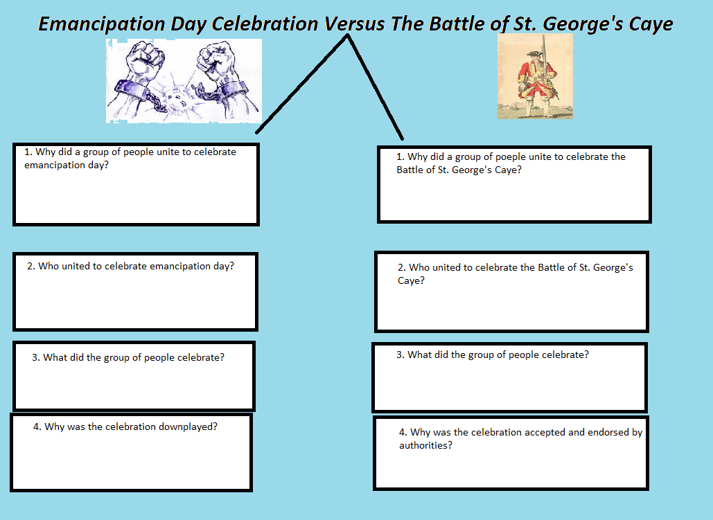

Topic 2: 1894 Riot
Activity 2: Key terms Puzzle.
Instructions: Circle the words outlined in the word-bank in the puzzle provided.

1894 Riot
H P F S O I S S S T D F S P H
M T R R N C N N E E W P T A L
F O M O B A A C V G T X N R R
S C I J F E C A R E A I A A R
A F E C Z I L I V E N W H M X
A F Q I D U T K A C A V C I R
Q L L J A T G E O M T S R L C
X E R T S O O M E J A O E I B
B D I J H I E F J R F J M T R
F O C U R R E N C Y I I S A I
N T S I C A R L Z X J N N R T
Y P V Z L Y P J M I A R G Y I
A R M W W X S T O D O Z V W S
C O N S T A B U L A R Y O O H
S N A I D A B R A B S L M V J

BARBADIANS
BELIZEANS
BRITISH
CONSTABULARY
CURRENCY
DEVALUATION
INCOME
INCREASE
JAMAICANS
LOW
MERCHANTS
PARAMILITARY
PROFITEERING
RACIST
RIOT
WAGES

Activity 3: Radio Advertisement.
Instructions: Imagine that you are a radio announcer in Belize City. Your radio station has a two-minute section called the historical blast and you are tasked with summarizing the 1894 riot. Create a script for the radio section outlining the major events in the 1894 riots.

Introduction:
__________________________________________________________________________________________________________________________________________________________________________________________________________________________________________________________________________________________________________________________________________________________________________________________________________________________________________________________________
Engaging body:
__________________________________________________________________________________________________________________________________________________________________________________________________________________________________________________________________________________________________________________________________________________________________________________________________________________________________________________________________________________________________________________________________________________________________________________________________________________________________________________________________________________________________________________________________________________________________________________________________________________________________________
Engaging conclusion:
__________________________________________________________________________________________________________________________________________________________________________________________________________________________________________________________________________________________________________________________________________________________________________________________________________________________________________________________________
Concluding slogan:
______________________________________________________________________________________________________________________________________________________________________________________________________________________________________________________________________________
Topic: Marcus Garvey
Activity 4: Life Timeline.
Instructions: Fill in the boxes provided detailing the life of Marcus Garvey.

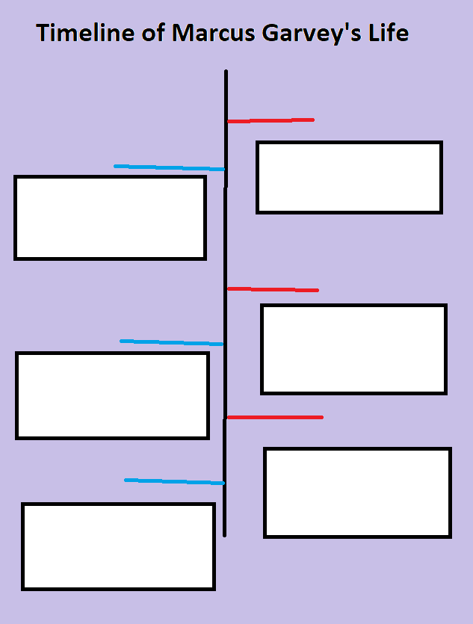
Activity 5. Portrait.
Instructions: In the box provided draw a sketch of Marcus Garvey’s face and put in the image events, people, and experiences that shaped his life. Please color the image using red, black, and yellow colors.

Topic: Garveyism
Activity 6: Emblems/logo and Summary.
Instructions: Using the boxes provided create an emblem to represent Garvey’s ideas on people, nation and his organization’s arms. Provide a thorough explanation for your emblem/logo.
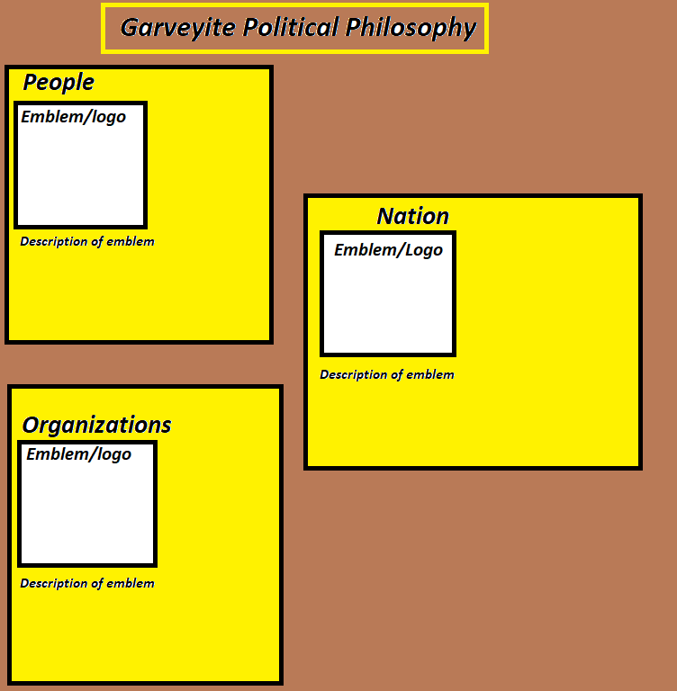

Activity 7: Letter to the Editor.
Instructions: Write a letter to the editor directed to Evan X Hyde of the Amandala Newspaper to explain to him why you think that Belizeans should know about Garveyism. Please ensure to greet the editor, mention your topic, describe philosophy of Garveyism, and why it is important for Belizeans.
__________________________________________________________________________________________________________________________________________________________________________________________________________________________________________________________________________________________________________________________________________________________________________________________________________________________________________________________________________________________________________________________________________________________________________________________________________________________________________________________________________________________________________________________________________________________________________________________________________________________________________________________________________________________________________________________________________________________________________________________________________________________________________________________________________________________________________________________________________________________________________________________________________________________________________________________________________________________________________________________________________________________________________________________________________________________________________________________________________________________________________________________________________________________________________________________________________________________________________________________________________________________________________________________________________________________________________________________________________________________________________________________________________________________________________________________________________________________________________________________________________________________________________________________________________________________________________________________________________________________________________________________________________________________________________________________________________________________________________________________________________________________________________________________________________________________________________________________________________________________________________________________________________________________________________________________________________________________________________________________________________________________________________________

Topic: World War 1
Activity 8: Cause and Effect Chart.
Instructions: Identify key moments in the history of World War 1 and place it in the cause and effect chart. Provide thorough descriptions for each and each cause and effect most relate to each other.
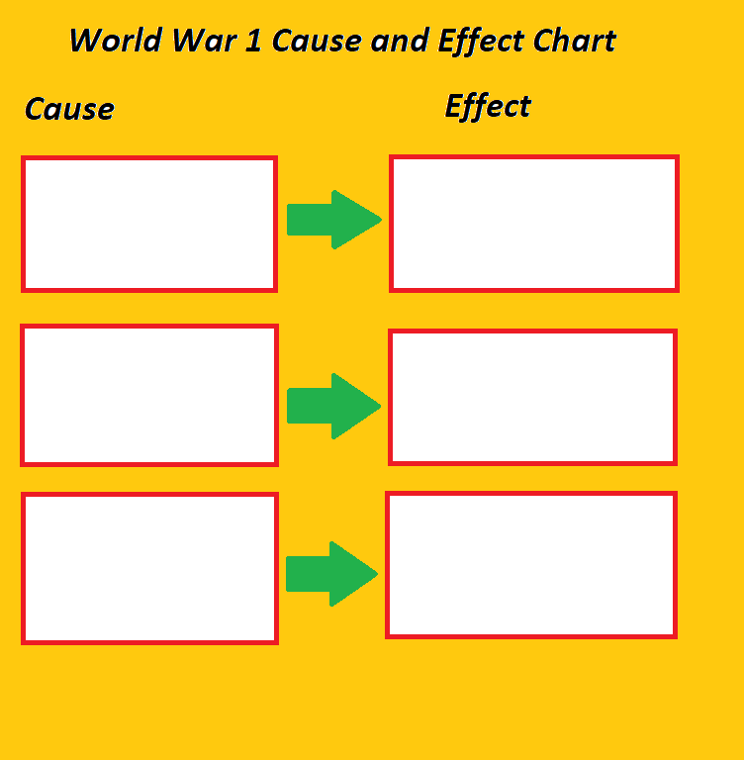

Activity 9: Newspaper Article.
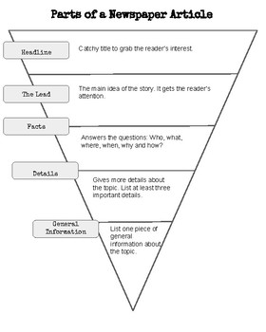
Instructions: Write a newspaper article, as if you were reporting of the events in World War 1 in 1918, to inform British Hondurans about the history of the war and its outcome.

______________________________________________________________________________________________________________________________________________________________________________________________________________________________________________________________________________________________________________________________________________________________________________________________________________________________________________________________________________________________________________________________________________________________________________________________________________________________________________________________________________________________________________________________________________________________________________________________________________________________________________________________________________________________________________________________________________________________________________________________________________________________________________________________________________________________________________________________________________________________________________________________________________________________________________________________________________________________________________________________________________________________________________________________________________________________________________________________________________________________________________________________________________________________________________________________________________________________________________________________________________________________________________________________________________________________________________________________________________________________________________________________________________________________________________________________________________________________________________________________________________________________________________________________________________________________________________________________________________________________________________________________________________________________________________________________________________________________________________________________________________________________________________________________________________________________________________________________________________________________________________________________
Topic: The Impact of World War 1 on British Honduras
Activity 10: Scenario Analysis.
Instructions: Read the scenario thoroughly and use grammatically correct sentences to answer the questions provided.
Scenario:
You are a father of three children, Toby is 10, Zaya is 8, and Ritchi is 3, you just got fired from the chicle camp because the company lost selling power. You come into the city and notice that the cost of living rose and you hear about people crying because they cannot access food to eat. You get into the desperation and also fear that in a week you will not be able to feed your children or your wife.
- What caused your firing?
________________________________________________________________________________________________________________________________________________________________________________________________________________________________________________________________________________________________________________________________________________________________________
- Why did your company lose selling power?
________________________________________________________________________________________________________________________________________________________________________________________________________________________________________________________________________________________________________________________________________________________________________
- Why did the cost of living rise in Belize Town?
________________________________________________________________________________________________________________________________________________________________________________________________________________________________________________________________________________________________________________________________________________________________________
- What do you think people will do as a result of feeling frustrated?
______________________________________________________________________________________________________________________________________________________________________________________________________________________________________________________________________________
- How do you feel that you cannot provide for your family?
______________________________________________________________________________________________________________________________________________________________________________________________________________________________________________________________________________
- What other events are affecting British Honduras at the time?
__________________________________________________________________________________________________________________________________________________________________________________________________________________________________________________________________________________________________________________________________________________________________________________________________________________________________________________________________
Activity 11: Graphic Organizer on WW1.
Instructions: Fill the boxes provided with information about the impact of World War 1 on British Honduras. The boxes are connecting in a descending order and the aspects discussed must relate to each other.
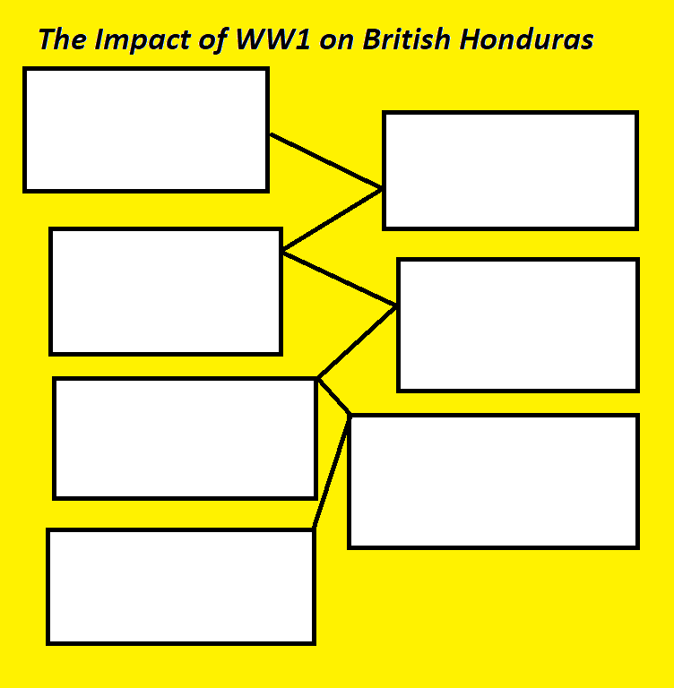

Topic: Recruitment
Activity 12: Quote Analysis.
Instructions: Analyze the quotes using the content based on the recruitment process.

- Collet (governor):
“It is not an easy matter to maintain discipline in an unpaid force consisting of men of different colours, ranging from pure white to almost pure black.”
________________________________________________________________________________________________________________________________________________________________________________________________________________________________________________________________________________________________________________________________________________________________________________________________________________________________________________________________________________________________________________________________________________________________________________________________________________________________________________________________________________________________________________________________________________
- Colonel Slack:
“I am firmly of the conviction that war does sometimes prove itself to be the cleansing power of humanity. . . . I know some of the mothers who did not want their boys to go. I have had some of you to see me. . . . But that body of that son that you brought into this world, what is the good of it, if it has not got a man’s spirit inside it. Will you be satisfied to have a son who shirks his duty? . . . I say it is an honour to these boys to be able to serve their King and their Country. Don’t let them hide behind your petticoats. . . . There is still the necessity for men to enlist. . . . [P]rove yourselves at this time that you are worthy sons of those worthy baymen of one hundred years ago.”
__________________________________________________________________________________________________________________________________________________________________________________________________________________________________________________________________________________________________________________________________________________________________________________________________________________________________________________________________________________________________________________________________________________________________________________________________________________________________________________________________________________________________________________________________________________________________________________________________________________________________________
- A mother:
“Ah . . . tenk de Lawd dat me son is a man an not ah slacka,”
____________________________________________________________________________________________________________________________________________________________________________________________________________________________________________________________________________________________________________________________________________________________________________________________________________________________________________________________________________________________________________________________________________________________

Topic: At War Racism
Activity 13: Drawing Scenes
Instructions: Use the boxes provided to draw and explain scenes of racism experienced by British Hondurans while at war.
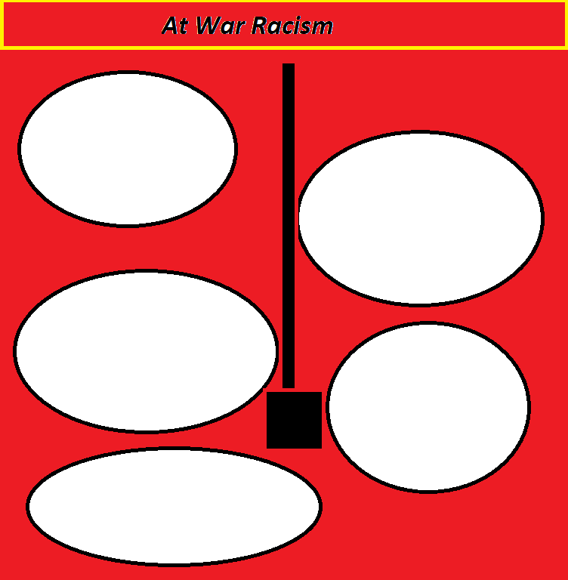

Topic: The Reception of Veterans
Activity 14: One Scene
Instructions: Draw and explain one scene exemplifying the racism experienced by war veterans although the events were organized in their honor.

Activity 15: Comic Strip
Instructions: Draw 6-sectioned comic strip based on the events at the reception of war veterans.

Topic: The Revolution
Activity 16: Filling the Timeline
Instructions: Fill out the chronology of events line following the logic of high points and low point in the events in the 1919 revolution.
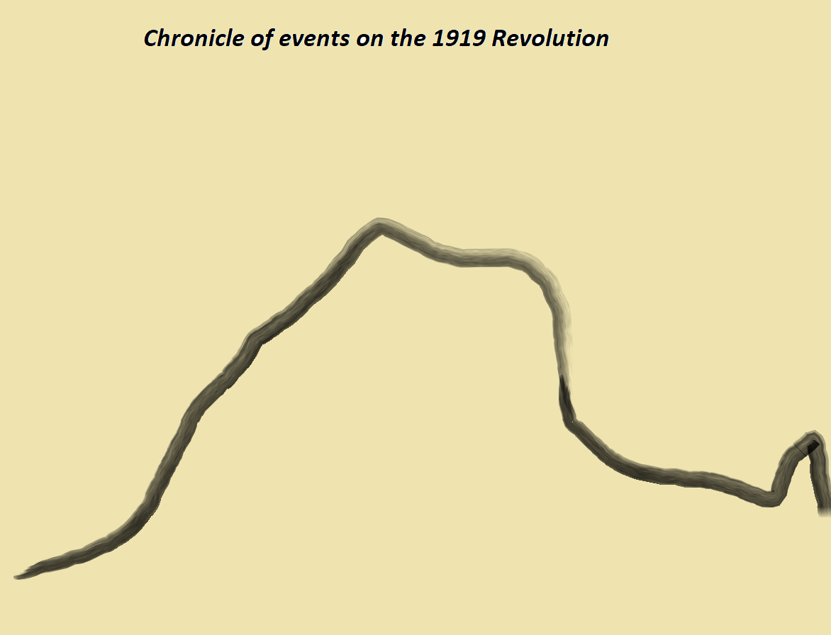

Activity 17: Quote Evaluation
Instructions: Analyze the quote provided.

- Samuel Haynes:
“If the truth were told, it was I whose appeal to sobriety and reason saved the handful of Europeans in Belize from a savage massacre when the returned soldiers rioted in an orgy of rum in the summer of 1919 . . . I rose to the occasion and silenced the radicals.”
_____________________________________________________________________________________________________________________________________________________________________________________________________________________________________________________________________________________________________________________________________________________________________________________________________________________________________________________________________________________________________________________________________________________________________________________________________________________________________________________________________________________________________________________________________________________________________________________________________________________________________________________________________________________________________________________________________________________________________________________________________________________________________________________________________________________________________________________________________________________________________________________________________________________________________________________________________________________________________________________________________________________________________________________________________________________________________________________________________________________________________________________________

Activity 18: Meme
Instructions: In the box provided create a meme based on the arrest of Rufus Hall. Ensure that your meme represents the conditions of his arrest and his sentence.

Activity 19: Political Propaganda
Instructions: Create a political slogan with a catchy graphic representation to advocate for a complete control of the settlement, as if you already knew about the revolution. This poster you plan to use during the revolution to inspire others to work towards a complete take-over of the settlement.

